Session 8: How to Use Jeddict AI Assistant in NetBeans 24
Jeddict AI Assistant is an AI-powered code assistant for Apache NetBeans that helps with code completion, refactoring, and intelligent suggestions. Below is a step-by-step guide on how to install and use it in NetBeans.
Step 1: Install Jeddict AI Assistant in NetBeans
Method 1: Install from NetBeans Plugin Portal
- Open NetBeans.
- Go to Tools → Plugins.
- Click on the Available Plugins tab.
- Search for Jeddict AI Assistant.
- Select the plugin and click Install.
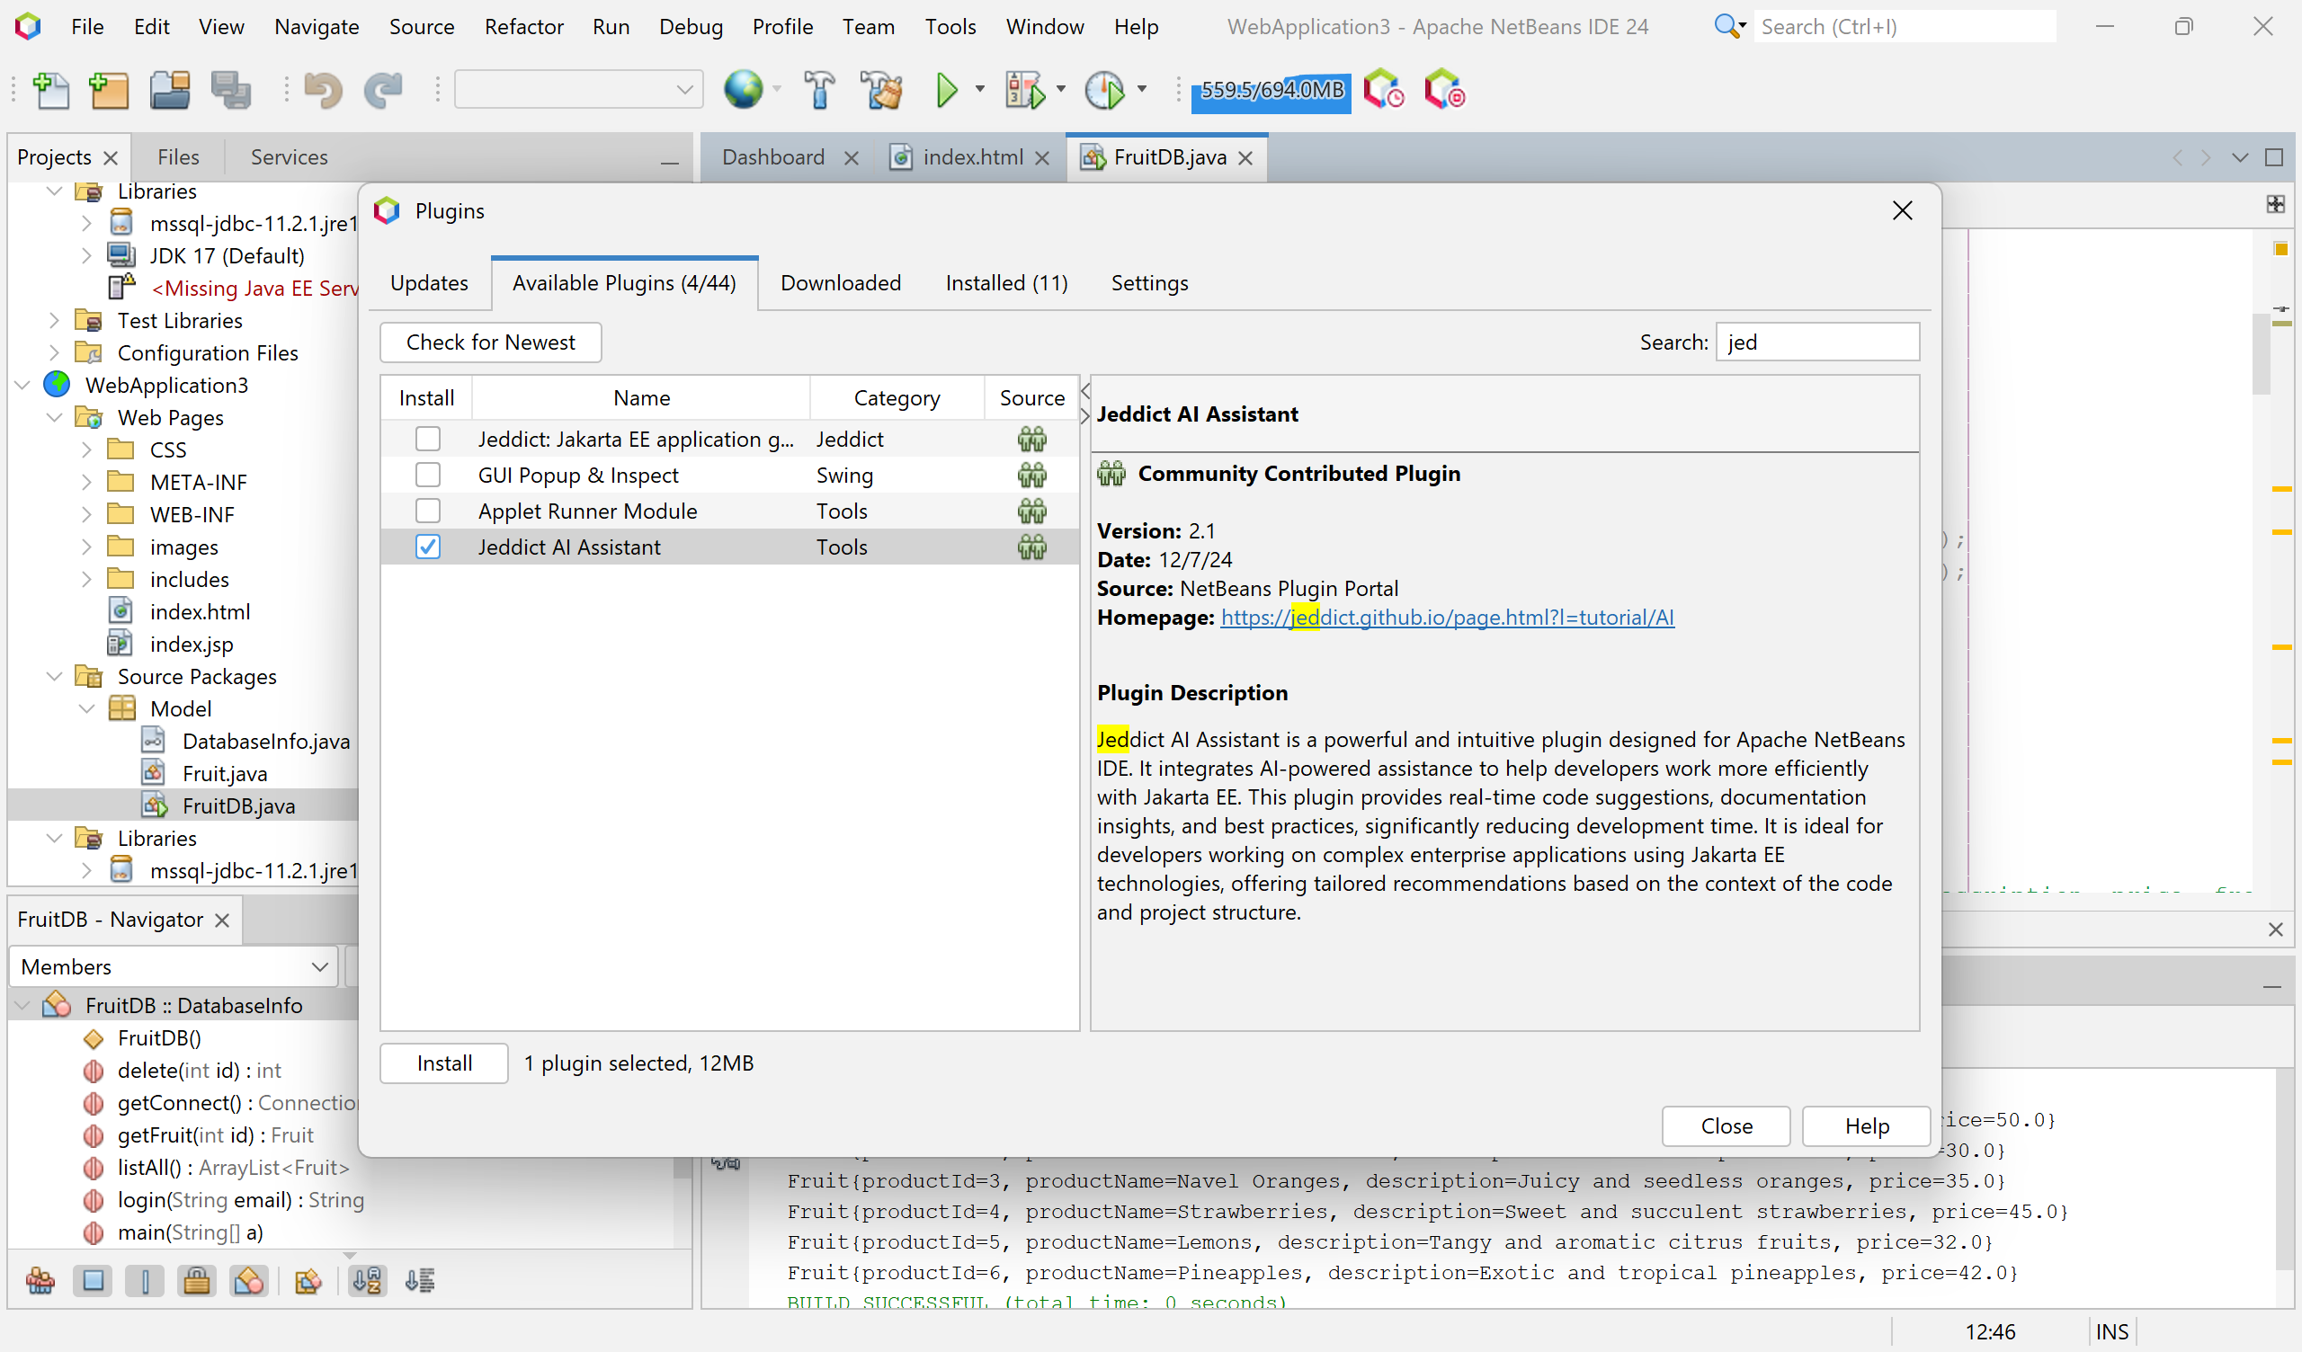
- Follow the installation steps and restart NetBeans.
Method 2: Install from a Downloaded File
- Download the Jeddict AI Assistant plugin (.nbm file) from the Apache NetBeans Plugin Portal.
- Open NetBeans and navigate to Tools → Plugins.
- Go to the Downloaded tab and click Add Plugins.
- Select the .nbm file and click Install.
- Complete the installation process and restart NetBeans.

Step 2: Activate Jeddict AI Assistant
- After installation, go to Tools → Options.
- Select the Jeddict AI Assistant tab.
- Enable AI-powered suggestions and adjust settings based on your preferences.
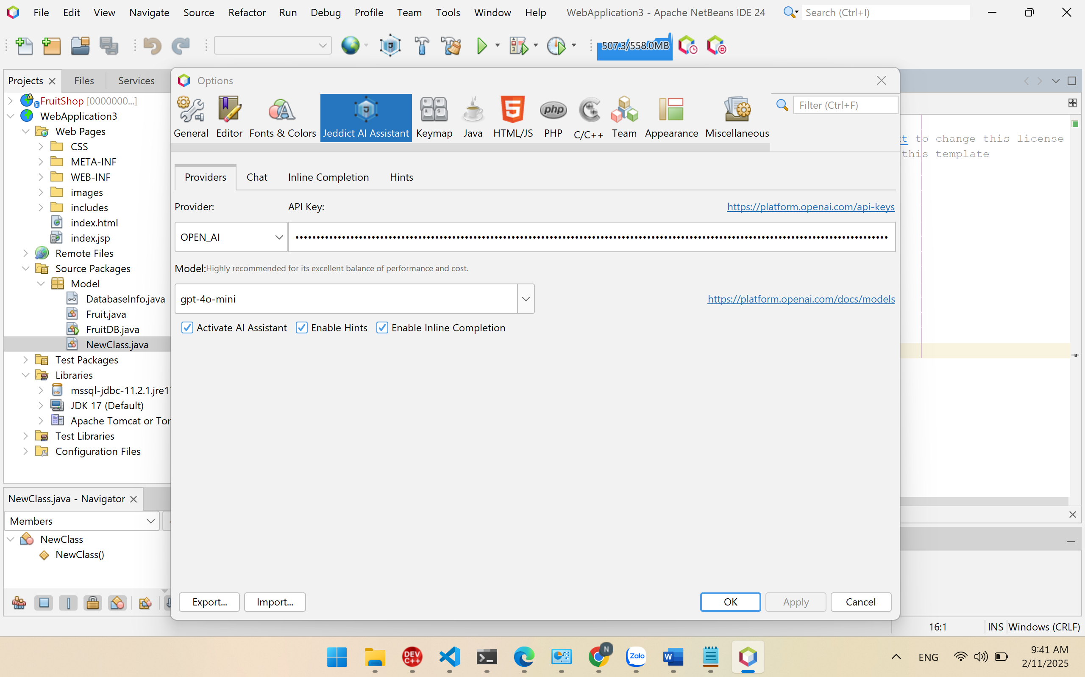

Step 3: Use Jeddict AI Assistant in NetBeans
1️. AI-Code Completion
- Start typing in your Java, PHP, or Python file.
- Jeddict AI Assistant will provide real-time code suggestions.
- Press Tab or Enter to accept a suggestion.
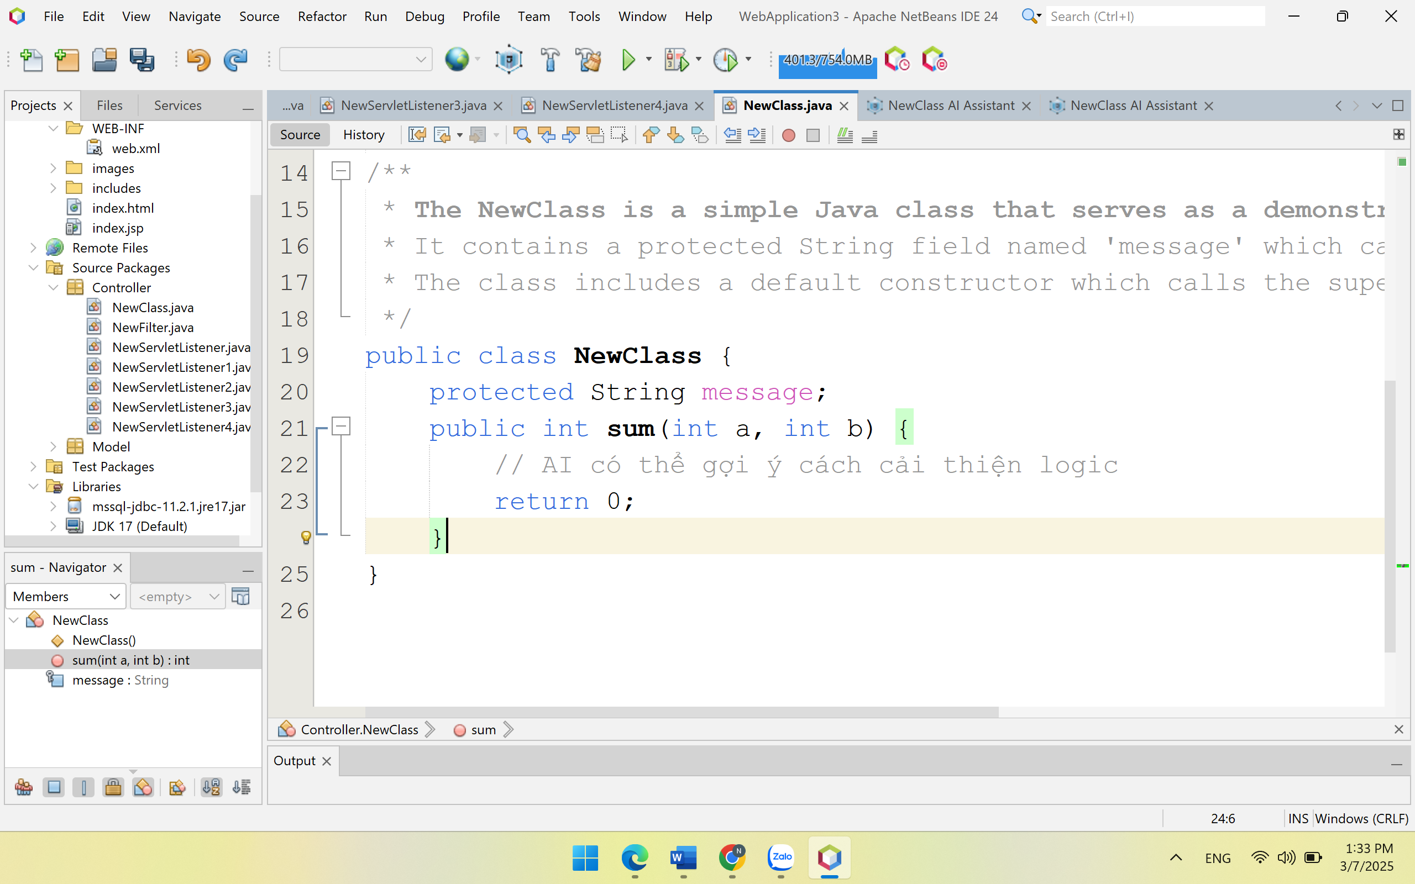
Click yellow icon below 23, click AI:Enhance the method
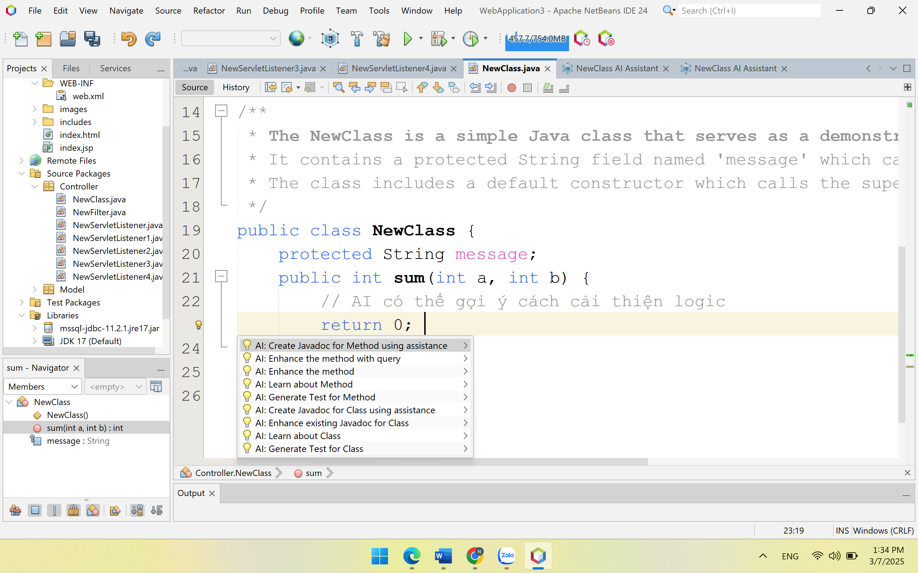

  - Result
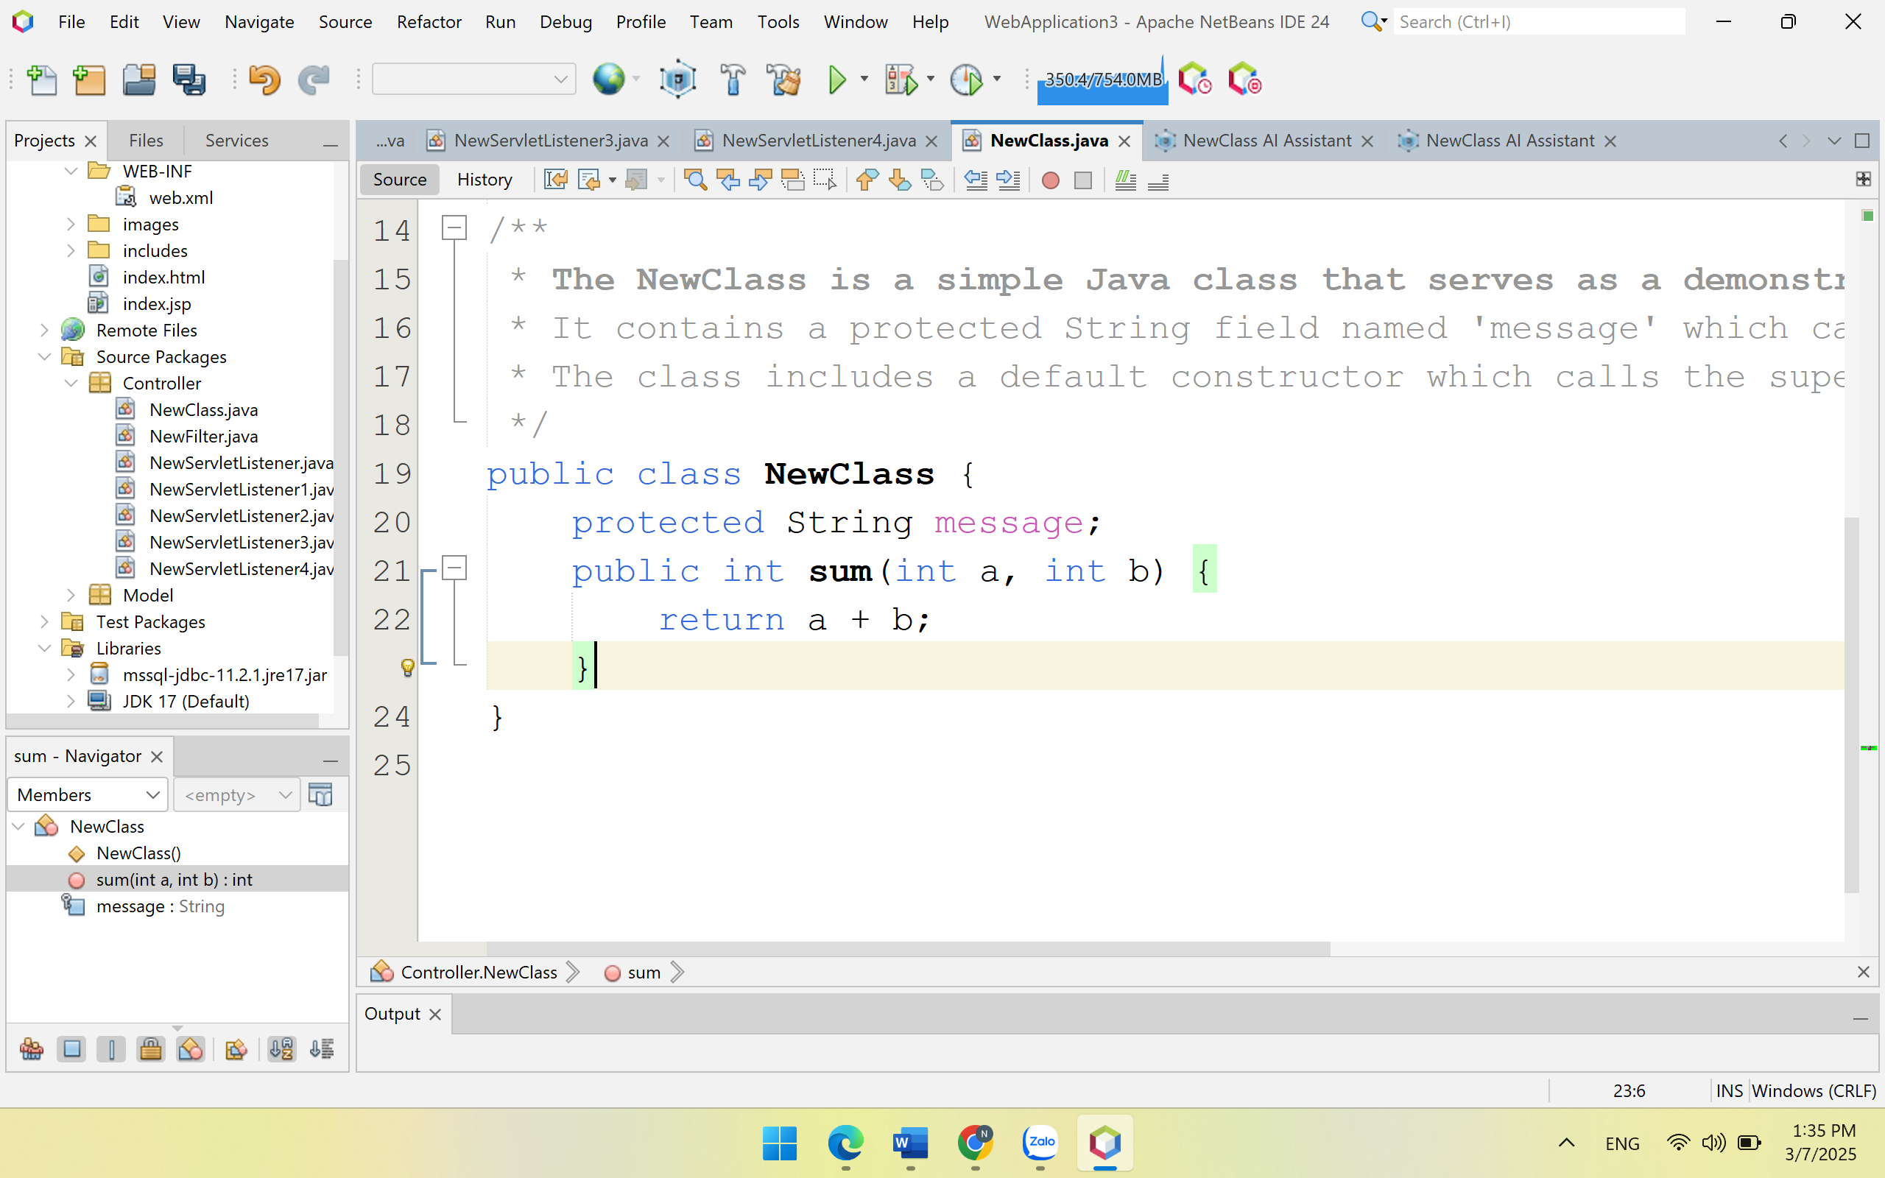
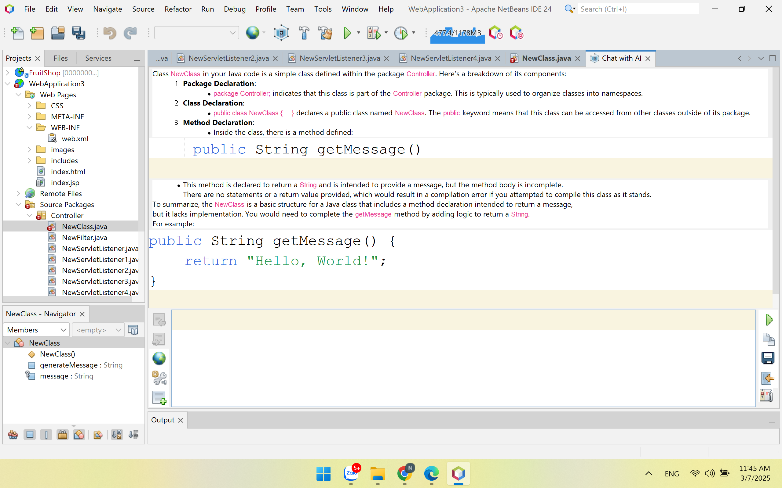
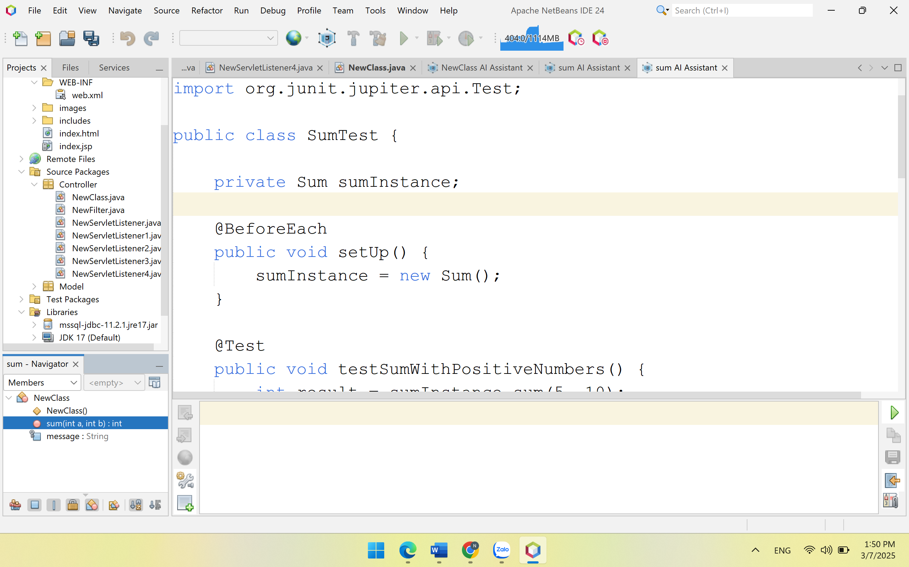
2. AI-Powered Refactoring
- Right-click on a piece of code.
- Select Refactor with AI.
- The AI will optimize and suggest improvements.
3️. AI-Code Explanation
- Highlight a code snippet.
- Right-click and choose Explain with AI.
- The AI will generate a detailed explanation of the selected code.
4️. AI-Bug Fixing
- If there are compilation errors, right-click on the error line.
- Select Fix with AI to get automated debugging suggestions.
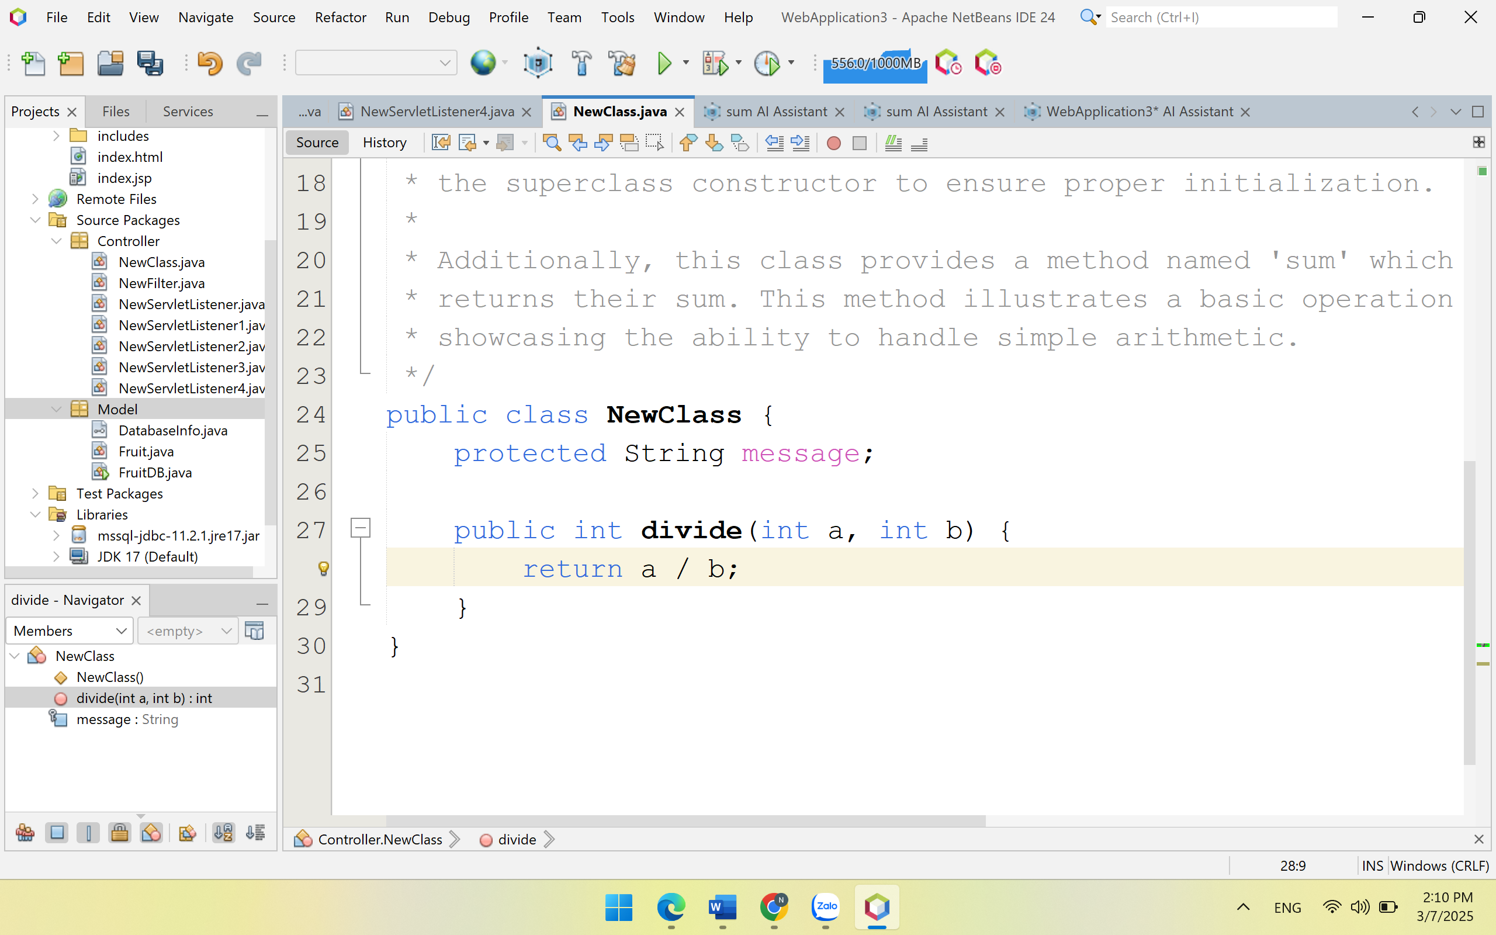
Enhance the method
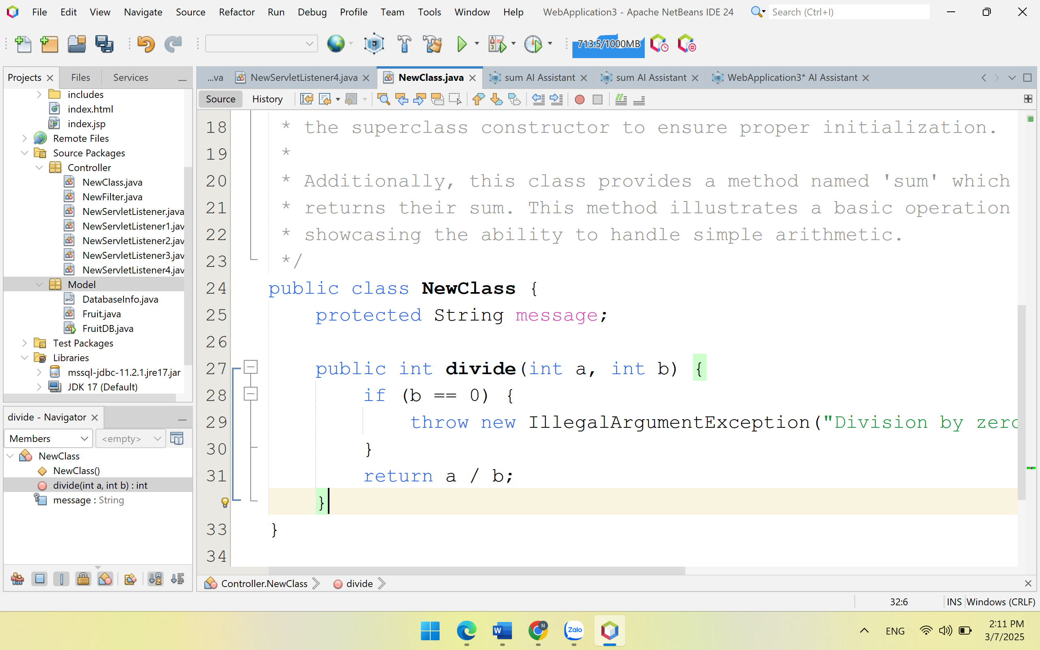
5️. AI-Code Generation
- You can generate boilerplate code (e.g., REST APIs, database models).
- Use the command: @AI Generate Entity to create entity classes automatically.
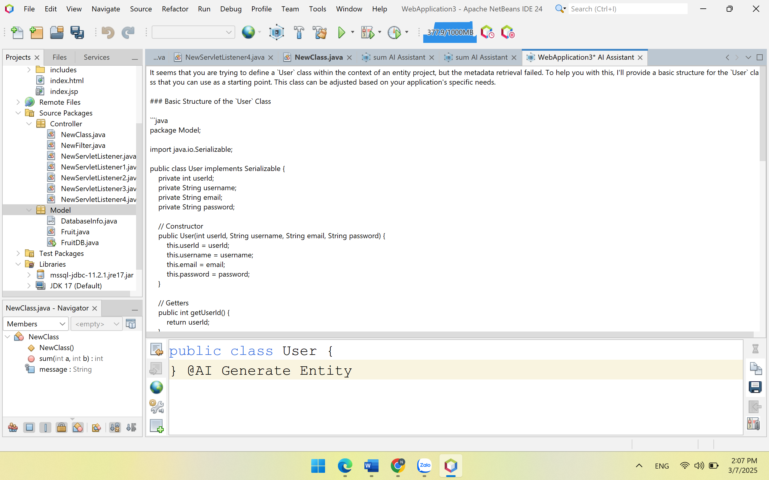

Step 4: Explore More Features
- AI-Enhanced ORM Modeling: Jeddict AI Assistant integrates with JPA ORM tools
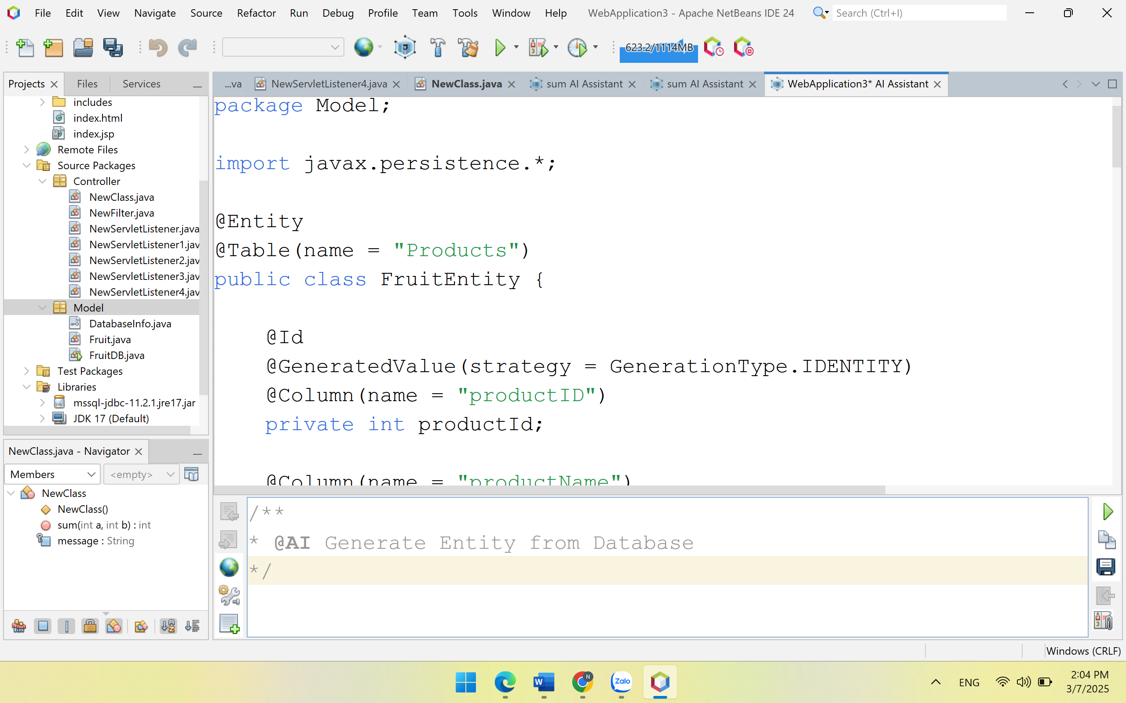
- Auto-Generate UML Diagrams: Convert Java code into UML models with AI assistance.
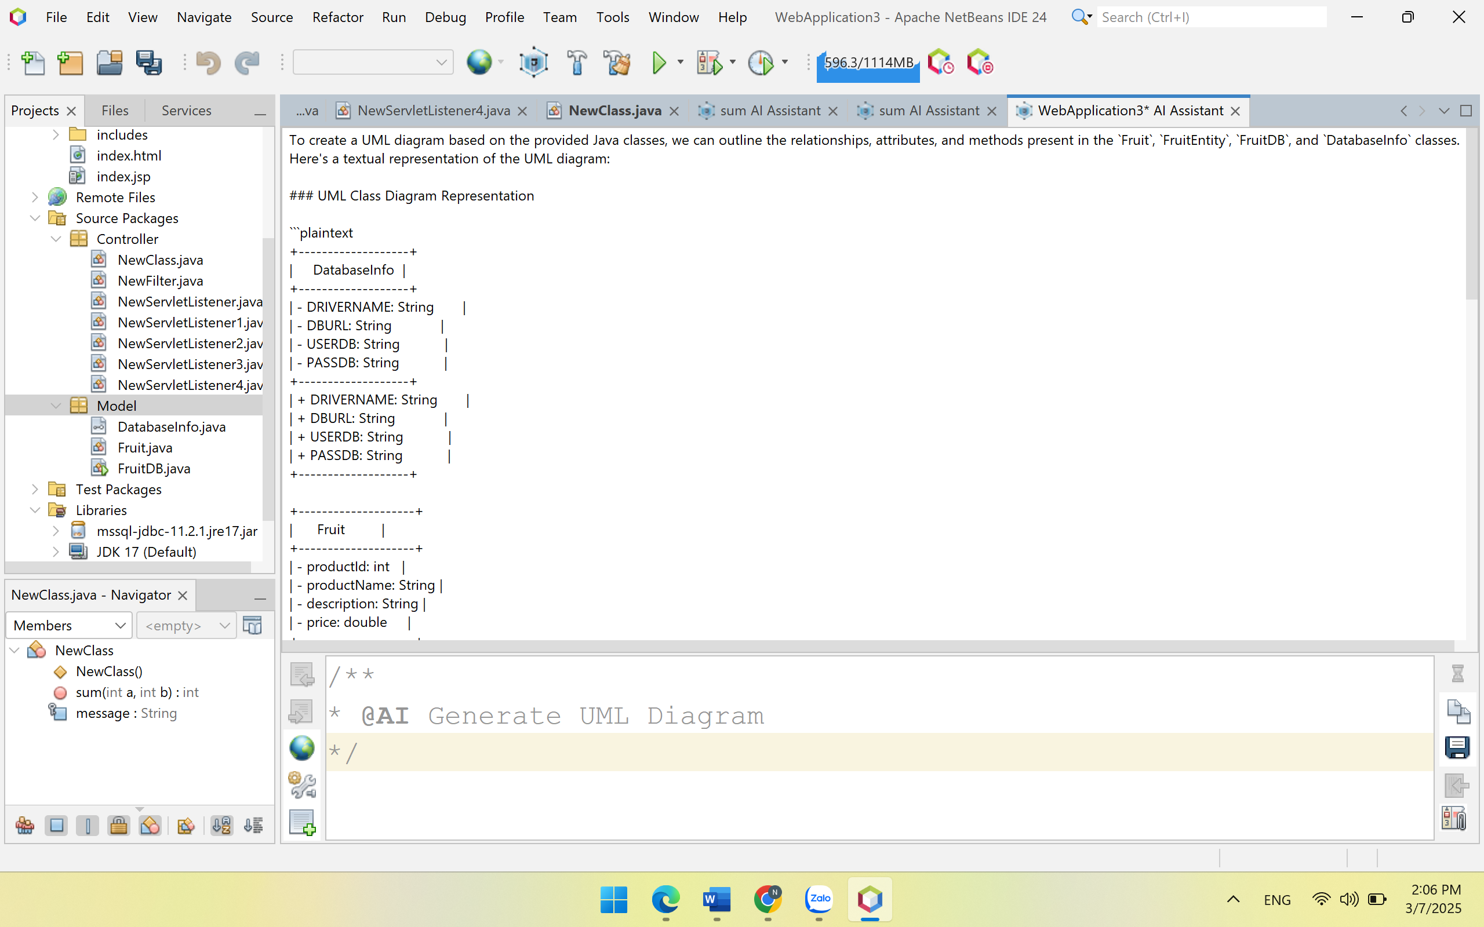
- Spring Boot Support: AI helps in generating Spring Boot applications.

Conclusion
Jeddict AI Assistant is a powerful AI-driven tool for Apache NetBeans that enhances coding productivity. It automates repetitive tasks, improves code quality, and helps with debugging. By following these steps, you can install, configure, and start using Jeddict AI Assistant efficiently in NetBeans.

